ABC Books - Data Modeling & Class Diagram Documentation

Conceptual Model:
This conceptual ER diagram represents the high-level business view of the ABC Books system. It focuses on identifying the main entities involved in book distribution such as Books, Authors, Publishers, Clients, Orders, Employees, Shipments, and Vendors, along with their relationships. This model avoids technical details and instead captures how the business operates and how core entities interact conceptually.
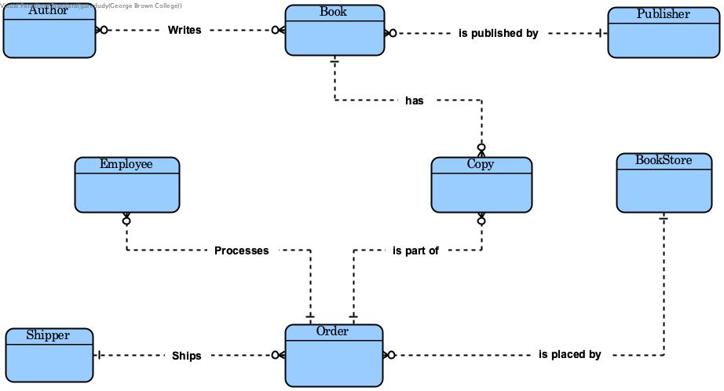

Logical Model:
The logical ER diagram expands on the conceptual model by defining attributes, primary keys, and relationships between entities. It represents how books, authors, clients, orders, shipments, and employees are structured logically, including many-to-many relationships and constraints. This model is database-independent and focuses on data integrity, normalization, and business rules.
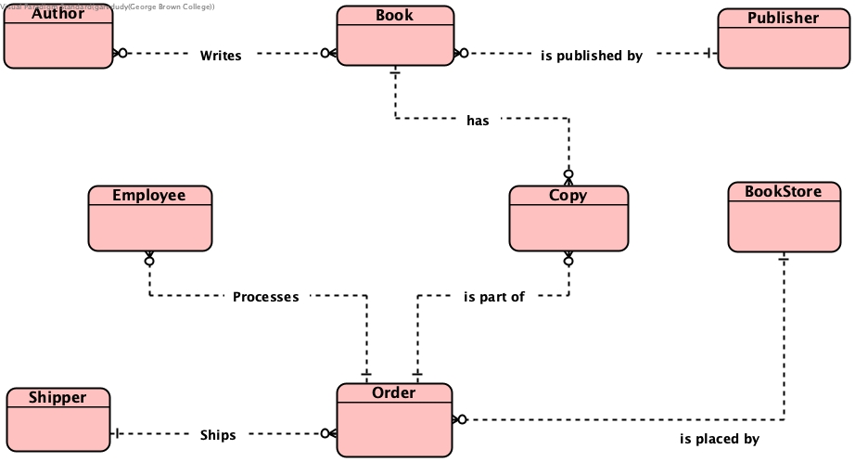

Physical Model:
The physical ER diagram shows the actual database implementation of the ABC Books system. It includes tables, column names, data types, primary and foreign key constraints, and junction tables required to support real-world operations. This model reflects how the data would be stored and managed in a relational database system.
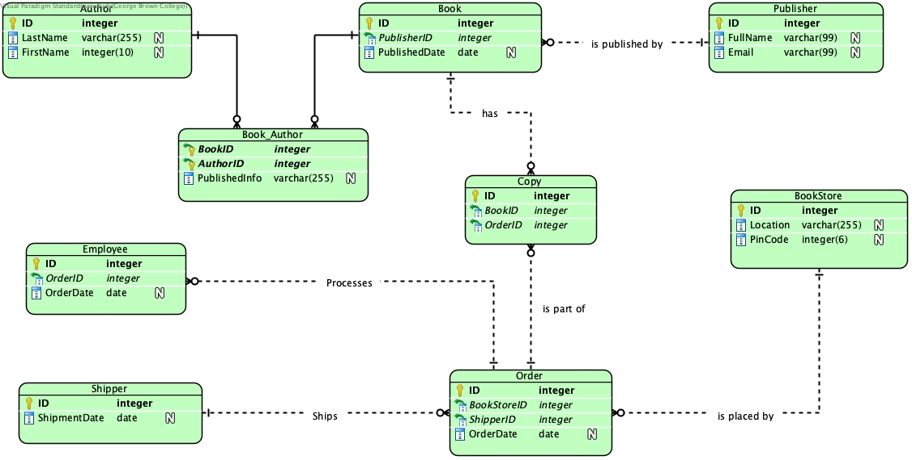
Class Diagram:
The class diagram represents the object-oriented view of the ABC Books system derived from the physical data model. It defines classes, attributes, associations, and relationships that would be used in application development. This diagram helps bridge the gap between database design and software implementation by modeling the system in an object-oriented structure.
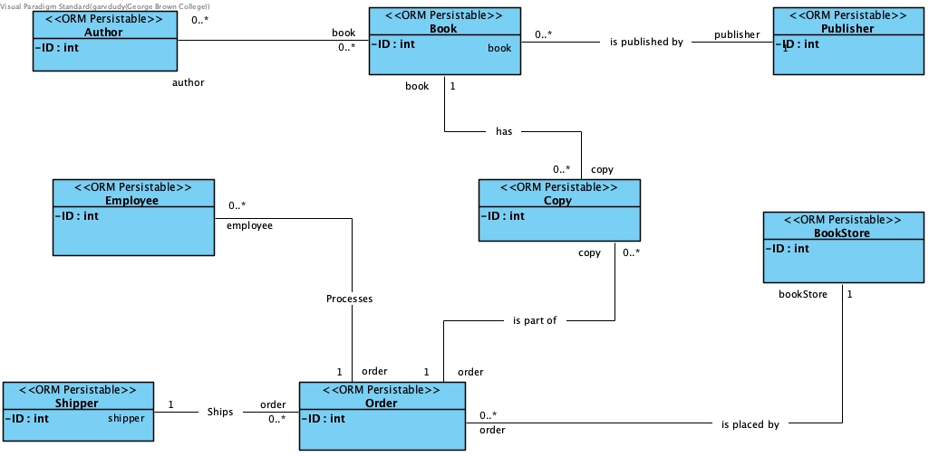

Case Study Summary
ABC Books is a book distribution company that supplies books to client bookstores. The system manages book inventory, authorship, publishers, customer orders, shipments, and pricing based on client loyalty and order volume. These models collectively represent the system from business understanding to database implementation and object-oriented design.

